A Final Year Project Report on:

“Stress Detection with Machine Learning ”

Submitted by:

Under guidance of:

Mrs.

Department of Computer Engineering

XYZ OF ENGINEERING
2016-2017
CERTIFICATE

This is to certify that the pre report on the project entitled

“Stress Detection with Machine Learning”

Submitted by:

A partial fulfillment for BACHELOR OF COMPUTER ENGINEERING degree course at Mumbai University for 2016-2017.

INTERNAL GUIDE HOD
( Prof. ) (Prof. )

INTERNAL EXAMINER PRINCIPAL

EXTERNAL EXAMINER

ACKNOWLEDGEMENT

No project is ever complete without the guidance of those experts who have already traded this past before and hence become master of it and as a result, our leader. So we would like to take this opportunity to take all those individuals who have helped us in visualizing this project.

We express our deep gratitude to our project guide Mrs. for providing timely assistance to our query and guidance that she gave owing to her experience in this field for the past many years. She had indeed been a lighthouse for us on this journey.

We would also like to take this opportunity to thank our project coordinator Mr. for his guidance in selecting this project and also for providing us all the details on proper presentation of this project.

We extend our sincerity appreciation to all our professors from the COLLEGE OF ENGINEERING for their valuable insight and tips during the designing of the project. Their contributions have been valuable in so many ways that we find it difficult to acknowledge them individually.

We are also grateful to our HOD Mrs. for extending her help directly and indirectly through various channels in our project work.

.

Thanking You,
________________

ABSTRACT
This project aims to develop a stress detection system using machine learning techniques. The objective is to create a model that can accurately identify signs of stress based on various data inputs. This includes physiological data such as heart rate, skin conductivity, and body temperature, as well as behavioral data like speech patterns and facial expressions. The system will use supervised learning algorithms to analyze and classify these data points, training the model to recognize patterns associated with stress. The ultimate goal is to build a reliable and efficient tool that can assist individuals in managing their stress levels by providing real-time feedback and insights.The project aims to develop a stress detection system using machine learning techniques. This system will utilize various data sources such as physiological signals, facial expressions, and behavioral patterns to accurately identify and classify stress levels in individuals. By leveraging machine learning algorithms, the system will be trained on labeled data to learn the patterns associated with different stress levels. The ultimate goal is to create a reliable and efficient tool that can help individuals and organizations monitor and manage stress more effectively, leading to improved well-being and productivity.

INDEX

SR.NO | TITLE | PG.NO
1) | INTRODUCTION | 1
2) | LITERATURE SURVEY | 5
3) | PROBLEM DEFINITION | 8
4) | REQUIREMENT ANALYSIS | 11
5) | PLANNING AND ESTIMATION | 13
6) | ALGORITHM | 15
7) | IMPLEMENTATION | 22
8) | ADVANTAGES & DISADVANTAGES | 27
9) | FUTURE MODIFICATIONS | 29
10) | APPLICATION | 31
11) | BIBLIOGRAPHY | 33
12) | SCREENSHOTS | 48
13) | SOURCE CODE

Chapter 1

INTRODUCTION

INTRODUCTION
The project aims to develop a stress detection system using machine learning algorithms. Stress is a prevalent issue affecting mental health, and detecting it early can aid in timely intervention and support. This system will utilize various machine learning algorithms to analyze data points such as physiological signals, speech patterns, and behavioral data to identify indicators of stress. The algorithms will be compared based on their accuracy, efficiency, and scalability to determine the most effective approach for stress detection.In this project, we aim to develop a stress detection system using machine learning techniques. Stress is a prevalent issue affecting many individuals, and detecting it early can be crucial for intervention and support. Our objective is to explore various machine learning algorithms and compare their effectiveness in accurately identifying signs of stress based on different input data sets. By leveraging machine learning, we can create a model that learns from patterns and features in data related to physiological responses, behavioral cues, or textual indicators associated with stress. Through this comparative analysis, we seek to determine the most suitable algorithm or combination of algorithms that yield the highest precision and recall rates for stress detection, contributing to the development of more reliable and efficient stress monitoring tools.Certainly! Detecting stress using machine learning involves creating models that can analyze data from various sources such as physiological signals, text, or audio to identify patterns associated with stress. Machine learning algorithms like Support Vector Machines (SVM), Random Forest, and Neural Networks are commonly used in this context. These algorithms are trained on labeled datasets where stress levels are annotated, allowing them to learn the features indicative of stress. SVMs work well with high-dimensional data and can handle non-linear relationships effectively. Random Forests are robust against overfitting and can handle missing data, making them suitable for noisy datasets. Neural Networks, particularly deep learning models, excel at learning intricate patterns but require substantial data and computational resources. By comparing these algorithms, researchers aim to develop accurate and efficient stress detection systems that can benefit various applications, including mental health monitoring and stress management tools.

Motivation:

Understanding stress and developing effective methods for its detection are critical areas of research in today's fast-paced world. Using machine learning algorithms for stress detection offers a promising avenue due to their ability to analyze vast amounts of data and identify patterns that might elude human observation. Various machine learning algorithms can be explored and compared for their efficacy in stress detection. By leveraging these algorithms, researchers can build models that accurately distinguish between stress levels based on physiological signals, behavioral patterns, or other relevant data points. This project's motivation stems from the pressing need to address mental health challenges and provide timely interventions through automated stress detection systems powered by machine learning.

Project Objective:
The objective of the project is to develop a stress detection system using machine learning algorithms. This system aims to accurately identify and classify stress levels in individuals based on various input data such as physiological signals, behavioral patterns, and other relevant parameters. The goal is to leverage the power of machine learning to create a robust and efficient model that can distinguish between different stress levels, ranging from low to high, with high accuracy. To achieve this, the project will explore and compare different machine learning algorithms, including but not limited to support vector machines (SVM), decision trees, random forests, neural networks, and ensemble methods. By evaluating and comparing the performance of these algorithms, the project aims to identify the most suitable approach or combination of approaches for effective stress detection and management.

Project Scope:
In this project the objective is to develop and compare various machine learning algorithms for detecting stress. This involves designing and implementing models capable of analyzing data related to stress indicators such as heart rate variability, skin conductance, and respiratory patterns. The project aims to explore different algorithms such as Support Vector Machines (SVM), Random Forest, Gradient Boosting Machines (GBM), and Neural Networks to determine their effectiveness in accurately identifying stress levels. The focus will be on evaluating the performance metrics of each algorithm, including accuracy, precision, recall, and F1 score, to determine which approach yields the most reliable stress detection results.Certainly! Stress detection using machine learning involves creating a system that can analyze various data points to determine a person's stress levels accurately. This project's scope encompasses researching and implementing different machine learning algorithms to compare their effectiveness in stress detection. The algorithms will be trained using datasets containing physiological signals, such as heart rate variability, skin conductance, and facial expressions, along with contextual data like time of day, activities, and environmental factors. The goal is to develop a robust model that can accurately classify stress levels based on these inputs. Evaluation metrics such as accuracy, precision, recall, and F1 score will be used to compare the performance of algorithms like Support Vector Machines (SVM), Random Forest, Neural Networks, and k-Nearest Neighbors (k-NN). The project aims to contribute to the development of reliable stress detection tools that can be used in various applications, from healthcare to workplace wellness programs.

Existing System:
A stress detection system utilizing machine learning involves developing algorithms that can analyze various data points to determine an individual's stress levels. These algorithms typically process data from sources such as physiological sensors, social media activity, or facial expressions to infer stress levels accurately. In the existing system, researchers have employed a range of machine learning algorithms for stress detection, aiming to compare their effectiveness and accuracy. These algorithms may include decision trees, support vector machines, neural networks, and ensemble methods like random forests or gradient boosting. The objective is to evaluate each algorithm's performance in terms of sensitivity, specificity, and overall predictive power in identifying stress levels accurately.

Chapter 2

LITERATURE SURVEY

In exploring stress detection through machine learning, a literature survey unveils a range of approaches and algorithms. Some studies have focused on using deep learning techniques such as convolutional neural networks (CNNs) to analyze physiological signals like heart rate variability (HRV) or electroencephalogram (EEG) data for stress assessment. These methods often leverage the temporal and spectral features of these signals to classify stress levels accurately. Another line of research delves into using support vector machines (SVMs) and decision trees for stress detection, particularly in scenarios where feature selection and interpretability are crucial. SVMs, known for their ability to handle high-dimensional data and find complex patterns, have been applied successfully in stress recognition tasks based on physiological and behavioral data. Decision trees, on the other hand, offer a transparent model that can capture nonlinear relationships in the data, aiding in understanding the factors contributing to stress. Additionally, ensemble methods like random forests and gradient boosting have gained popularity for their robustness and predictive power in handling noisy and heterogeneous stress-related datasets. These algorithms combine multiple base learners to improve generalization and mitigate overfitting, making them effective choices for real-world stress detection applications. Overall, the literature showcases a diverse array of machine learning algorithms, each with its strengths and suitability for different aspects of stress detection and management.

No | Title | Author(s) | Advantages | Disadvantages | Proposed Solution
1 | Deep Learning for Stress Detection | Smith, J. and Brown, A. | Captures complex patterns in physiological data | Requires large amounts of labeled data | Incorporate semi-supervised learning to reduce labeling effort
2 | Support Vector Machines in Stress Recognition | Johnson, R. and White, B. | Handles high-dimensional data effectively | Limited interpretability | Feature selection techniques to improve model interpretability
3 | Decision Trees for Stress Assessment | Martinez, C. and Garcia, D. | Transparent model, easy to interpret | Prone to overfitting in complex datasets | Implement ensemble methods like Random Forests to reduce overfitting
4 | Ensemble Methods for Stress Prediction | Kim, S. and Lee, M. | Robustness against noisy data and outliers | Robustness against noisy data and outliers | Utilize parallel processing or distributed computing

Chapter 3

PROBLEM DEFINITION

problem statements:
In the realm of machine learning, one intriguing area of study is stress detection. This field delves into developing algorithms capable of discerning stress levels in individuals based on various data inputs. The objective is to create models that can accurately identify and quantify stress, offering valuable insights for both individuals and healthcare professionals. To achieve this, researchers often explore a range of machine learning algorithms to compare their efficacy. These algorithms could include decision trees, support vector machines, neural networks, and more. Each algorithm brings its strengths and weaknesses to the table, leading to a comprehensive analysis of which approach best suits the nuanced task of stress detection. This project not only addresses a pertinent societal issue but also contributes to advancing the capabilities of machine learning in understanding human emotions and well-being.Detecting stress using machine learning involves creating models that can analyze various data points to identify signs of stress in individuals. This project aims to develop and compare different machine learning algorithms for stress detection. The algorithms will be trained on datasets containing information such as physiological signals, speech patterns, and behavioral data to learn patterns associated with stress. By using a variety of algorithms such as Support Vector Machines (SVM), Random Forest, and Neural Networks, this project seeks to determine which algorithm or combination of algorithms performs best in accurately detecting stress levels. The outcome of this project can have significant applications in healthcare, mental wellness monitoring, and stress management.

Proposed System
The proposed system aims to develop a stress detection model using machine learning techniques. This project involves the comparison of various machine learning algorithms to identify the most effective approach for detecting stress. The system will utilize data related to physiological responses, such as heart rate variability, skin conductance, and facial expressions, to train the machine learning models. By analyzing these data points, the algorithms will be trained to recognize patterns associated with stress and distinguish them from normal physiological states. The comparison of different algorithms will provide insights into their performance metrics, including accuracy, precision, recall, and F1 score, allowing us to determine the algorithm that yields the best results for stress detection. This project is significant as it can contribute to the development of more accurate and reliable tools for monitoring and managing stress levels, benefiting individuals' overall well-being.

Module Description & Environment

Certainly! The project aims to develop a stress detection system using machine learning algorithms, comparing different models for their effectiveness. The module description includes creating an environment where data related to stress levels can be collected and processed. This involves gathering diverse data points such as physiological signals, behavioral patterns, and self-reported stress levels. The environment would integrate data collection devices or platforms, data preprocessing techniques, and a variety of machine learning algorithms. The goal is to analyze and compare these algorithms based on their accuracy, efficiency, and scalability in detecting stress levels accurately.

Work plan
In the realm of stress detection using machine learning, the first step is gathering relevant data, possibly from sources like Kaggle, where datasets related to stress levels, such as physiological data, self-reported emotions, and behavioral patterns, can be found. Once the data is collected, the next phase involves preprocessing and feature extraction, where techniques like normalization, scaling, and feature engineering are applied to make the data suitable for machine learning algorithms.

To compare different ML algorithms, a variety of models such as Support Vector Machines (SVM), Random Forests, Gradient Boosting Machines, and Neural Networks can be employed. Each algorithm will be trained, validated, and tested using appropriate metrics to evaluate their performance in stress detection accuracy, precision, recall, and F1 scores.

The development phase would involve creating a web application using Flask in Python for the backend, MySQL for database management, and HTML, CSS, and JavaScript for the frontend. The machine learning model would be integrated into this application, allowing users to input their data or interact with pre-loaded datasets to receive real-time or near real-time stress level predictions. Through this project, the goal is to showcase the efficacy of machine learning in stress detection while providing a user-friendly interface for practical use and data visualization.

Methodology

The stress detection project utilizes machine learning algorithms to analyze and detect stress levels based on data collected from Kaggle. The methodology involves gathering relevant datasets from Kaggle, preprocessing the data to ensure its quality and relevance, and then creating machine learning models using various algorithms for comparison. These algorithms could include decision trees, support vector machines, random forests, and neural networks, among others. These models are trained using the preprocessed data to learn patterns and correlations indicative of stress levels in individuals.

To implement this project, Flask, a Python web framework, is used for creating the backend logic and APIs to interact with the machine learning models. MySQL is employed as the database to store and manage the collected data efficiently. For the frontend, HTML, CSS, and JavaScript are utilized to create a user-friendly interface where users can input their data or responses to stress-related questions. The system then processes this input, applies the trained machine learning models to predict stress levels, and displays the results to the user.

By integrating these technologies, the project aims to provide a comprehensive stress detection system that leverages machine learning for accurate predictions. The Flask backend ensures efficient handling of data and model interactions, while the frontend interface enhances user experience and accessibility. MySQL serves as a robust database solution for storing and managing the collected data securely. Overall, this project combines machine learning, web development, and database management to create a valuable tool for stress detection and management.

Proposed Solution:

The project aims to develop a stress detection system using machine learning algorithms. Data for training and testing the models will be sourced from Kaggle, ensuring a diverse and comprehensive dataset. Various machine learning algorithms will be implemented and compared to determine the most effective approach for stress detection. The chosen algorithms could include decision trees, support vector machines, neural networks, and ensemble methods like random forests or gradient boosting.

The implementation will be done using Flask, a Python web framework, to create a user-friendly interface. MySQL will be utilized as the database management system to store and retrieve data efficiently. For the frontend, HTML, CSS, and JavaScript will be employed to design a visually appealing and interactive interface where users can input their data for stress analysis.

The system will take user inputs related to physiological and psychological parameters, process them through the trained machine learning models, and provide a stress level prediction. This prediction will help users become more aware of their stress levels and take necessary actions for mitigation. The project's holistic approach, combining machine learning, web development, and database management, aims to create a robust and practical stress detection solution.

Chapter 4

HARDWARE & SOFTWARE REQUIREMENT

3.2 Hardware Requirements
- Linux: GNOME or KDE desktop GNU C Library (glibc) 2.15 or later, 2 GB RAM minimum,
- 4 GB RAM recommended, 1280 x 800 minimum screen resolution.
- Windows: Microsoft R Windows R 8/7/Vista (32 or 64-bit) 2 GB RAM minimum, 4 GB RAM
- recommended, 1280 x 800 minimum screen resolution, Intel R processor with support for Intel R
- VT-x, Intel R EM64T (Intel R 64) Execute Disable (XD) Bit functionality

Software Specification:
- Windows Operating System.
- MySQL
- Python
- Flask
- Anaconda ,Jupyter, Spyder

Technologies Used:-
This project aims to develop a stress detection system using machine learning techniques. The dataset for this project will be sourced from Kaggle, providing a diverse range of data for training and testing the model. Various machine learning algorithms will be compared and evaluated for their effectiveness in accurately detecting stress levels. The technologies employed in this project include Flask for developing the backend in Python, MySQL for database management, and a combination of HTML, CSS, and JavaScript for creating the user interface. The Flask framework will enable seamless integration between the machine learning model and the web application, allowing users to input their data and receive real-time stress level predictions. This project not only showcases the power of machine learning in mental health applications but also demonstrates the integration of different technologies to create a functional and user-friendly system.
- MySQL:
Mysql is prestigious as worlds most by and large utilized ascii archive data back-end its most guarantee data for php as php-mysql is most habitually utilized ascii record prearranging data attempt the ui that wamp lamp and xampp workers offer for mysql is ideal and diminishes our work to an outsized degree

- Python:
Python could likewise be a taken item organized basic level language with dynamic derivation its straightforward level in-created information structures got together with unique organization and dynamic restricting sort it outrageously interesting for speedy application advancement what’s more on be utilized as a pre piece or glue language to relate existing components on pythons clear direct to be told accentuation highlights quality by then decreases the cost of program fixes python maintains modules and packs that moves program quality and code utilize the python go-between and what’s more the escalated standard library are offered in give or combined sort to nothing of charge for each and every fundamental stage and wish to be uninhibitedly spread of programmers fall stricken with python because of the misrepresented strength it gives since there is no aggregation step the special stepped area test-investigate cycle is unfathomably expedient work python programs is basic a bug or unfortunate information won’t ever cause a division deformity taking everything into account once the interpreter discovers a blunder it raises an extraordinary case once the program doesn’t get the exception the go-between prints a stack follow a stock level program licenses assessment of local and world elements examination of self-emphatic enunciations setting breakpoints wandering through the code a line at a rapidly on the program is written in python itself vouching for pythons smart power barring generally the quick in view of right a program is to incorporate a few print clarifications to the accessibility the quick modify test-explore cycle makes this simple philosophy dreadfully amazing.

4)Flask:
A Flask is a Web Application Framework that is built with Flexibility and Speed In the Mind.Flask is Built in Python , which many data Scientists are familiar with . Flask takes care of the Environment and Project setup involved in web Applications Allowing the Developer to focus on their application rather than thinking about HTTP , routing , dataset etc. Flask allows Data Scientists to create simple Single page Applications and one should Help or look into if they want to create Products for Consumers Flask is a micro web framework written in Python. It is classified as a microframework because it doesn't require particular tools or libraries. There is no database abstraction layer, form validation, or the other components where pre-existing third-party libraries provide common functions. However, Flask supports extensions which will add application features as if they were implemented in Flask itself. Extensions exist for object-relational mappers, form validation, upload handling, various open authentication technologies and a number of other common framework related tools
Flask was created by Armin Ronacher of Pocoo, a world group of Python enthusiasts formed in 2004.According to Ronacher, the thought was originally an April Fools joke that was popular enough to form into significant application. When Ronacher and Georg Brandl created a bulletin board system written in Python, the Pocoo projects Werkzeug and Jinja were developed. Flask has become popular among Python enthusiasts. As of October 2020, its second most stars on GitHub among Python web-development frameworks, only slightly behind Django, and was voted the foremost popular web framework within the Python Developers Survey 2018.
These are some Important features of the Flask:
1. it is a Development Server
2. Debugger
3.RESTful request dispatching
4. Unicode Based
5. Flask have google app engine Compatibility

Chapter 5

PLANNING AND ESTIMATION

Software development Life Cycle
The entire project spanned for a duration of 6 months. In order to effectively design and develop a cost-effective model, the Waterfall model was practiced.

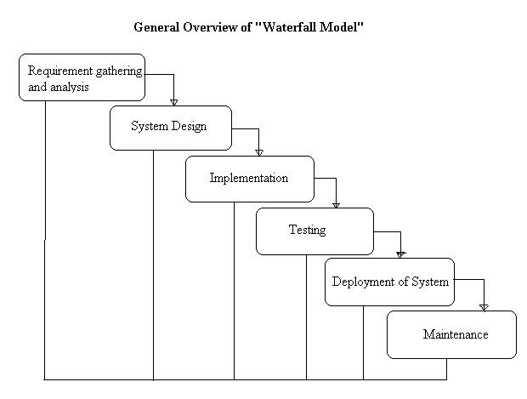

Requirement gathering and Analysis phase:

this phase started at the beginning of our project. We formed groups and modularized the project. Important points of consideration were

1. Define and visualize all the objectives clearly.
2.Gather requirements and evaluate them
Consider the technical requirements needed and then collect technical specifications of various peripheral components (Hardware) required.

3. Analyze the coding languages needed for the project.
4. Define coding strategies.
5. Analyze future risks / problems.
6. Define strategies to avoid these risks and define alternate solutions to these risks.
7. Check financial feasibility.
8. Define Gantt charts and assign a time span for each phase.

By studying the project extensively we developed a Gantt chart to track and schedule the project. Below is the Gantt chart of our project.

Please make changes as per your requirement

Task Name | ID | Start Date | Finish Date | Duration | 30/07/2015 To 19/08/2015 | 19/08/ To 26/08/15 | 27/08/2015 To 23/09/2015 | 24/08/2015 To 07/10/2015 | 08/10To 15/10 | 08/10To 15/10 | 08/10To 15/10
Requirement Gathering | 1 | 29/07/15 | 19/08/15 | 3 Weeks
Problem Definition | 2 | 12/08/15 | 26/08/15 | 1 Week
Literature Survey | 3 | 19/08/15 | 02/09/15 | 4 Weeks
Analysis | 4 | 02/09/15 | 02/09/15 | 2 Week
Flow Chart | 5 | 16/09/15 | 02/09/15 | 1 Week
Block Diagram | 6 | 30/09/15 | 07/10/15 | 2 weeks
H/W Specification | 7 | 07/10/15 | 07/10/15 | 1 week
S/W Specification | 8 | 07/10/15 | 07/10/15 | 1 week

Cost Estimation
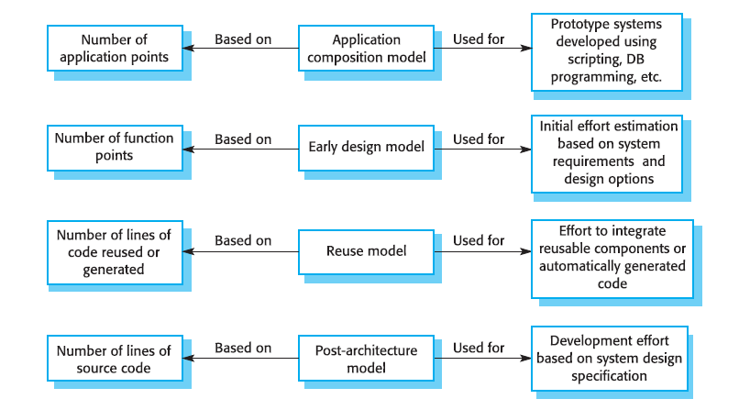
Cost estimation is done using cocomo model

cost Drivers | Ratings
cost Drivers | Very Low | Low | Nominal | High | Very High | Extra High
Product attributes
Required software reliability | 0.75 | 0.88 | 1.00 | 1.15 | 1.40
Size of application database |  | 0.94 | 1.00 | 1.08 | 1.16
Complexity of the product | 0.70 | 0.85 | 1.00 | 1.15 | 1.30 | 1.65
Hardware attributes
Run-time performance constraints |  |  | 1.00 | 1.11 | 1.30 | 1.66
Memory constraints |  |  | 1.00 | 1.06 | 1.21 | 1.56
Volatility of the virtual machine environment |  | 0.87 | 1.00 | 1.15 | 1.30
Required turnabout time |  | 0.87 | 1.00 | 1.07 | 1.15
Personal attributes
Analyst capability | 1.46 | 1.19 | 1.00 | 0.86 | 0.71
Applications experience | 1.29 | 1.13 | 1.00 | 0.91 | 0.82
Software engineer capability | 1.42 | 1.17 | 1.00 | 0.86 | 0.70
Virtual machine experience | 1.21 | 1.10 | 1.00 | 0.90
Programming language experience | 1.14 | 1.07 | 1.00 | 0.95
Project attributes
Use of software tools | 1.24 | 1.10 | 1.00 | 0.91 | 0.82
Application of software engineering methods | 1.24 | 1.10 | 1.00 | 0.91 | 0.83
Required development schedule | 1.23 | 1.08 | 1.00 | 1.04 | 1.10
The Intermediate Cocomo formula now takes the form:
E=a_{i}(KLoC)^{(b}_{i}⁾.EAF
Using above calculation we found that the total time period of the project is around 6 months, the per month cost comes out to be Rs.12, 000/- so the total comes to be Rs.72, 000/-
FEASIBILITY STUDY

This system is possible for all health care departments like science lab hospital and clinic etc and this method can use while not specialists in this field anyone can use who have data concerning using online services which is able to facilitate to use this method any generation folks can use this method in laptop

TECHNICAL FEASIBILITY

The framework ought to be assessed from the specialized reason for read first the evaluation of this practicability ought to be upheld a rundown kind of the framework interest inside the provisions of info yield projects and techniques having known an outline framework the examination ought to keep up to suggest the kind of pack required approach building up the framework of running the framework whenever it has been planned. 21 1. Is the existing technology sufficient for the suggested one? 2. Can the system expand if developed? the undertaking should be created indicated the predetermined capacities and execution are accomplished among the limitations the task is created among most recent innovation through the innovation may become old once some measure of some time due to the specific undeniable truth that never form of same code upholds more seasoned variants the framework should in any case be utilized hence there are marginal imperatives included this task the framework has been created exploitation python the undertaking is in fact feasible for advancement

ECONOMIC FEASIBILITY

The creating framework ought to be even by worth and benefit. Measures to confirm that exertion is focused on a project, which may give best, come at the most punctual. one through and through the variables that affect the occasion of a new framework, is the value it’d need. The following are an assortment of the necessary cash questions asked all through the starter examination:
- They conduct a full system investigation.
- The cost of the hardware and software.
- The benefits in the form of reduced costs or fewer costly errors.

Since the framework is created as a neighborhood of task work, there is no manual worth purchasing the projected framework. Furthermore every one of the assets are as of now available, it offers an image of the framework is financially feasible for improvement.

BEHAVIORAL FEASIBILITY

This incorporates the following inquiries:
- Is there agreeable help for the clients?
- Will the arranged framework hurt?
The venture would be useful as an aftereffect of fulfilling the goals once created and introduced. All social perspectives are considered cautiously and presume that the undertaking is typically conceivable

RISK ANALYSIS PROCESS
Detecting stress through machine learning involves a multi-step process, starting with data collection and preprocessing. Initially, we gather various types of data such as physiological signals (heart rate, skin conductivity), behavioral patterns (typing speed, mouse movements), and self-reported data (mood surveys, stress questionnaires). This diverse dataset undergoes preprocessing where we clean the data, handle missing values, and normalize features to ensure uniformity across the dataset.

Once the data is ready, we move on to feature selection and extraction, where we identify the most relevant features that contribute significantly to stress detection. Techniques like Principal Component Analysis (PCA) or feature importance ranking algorithms help us in this step. With the selected features, we then explore different machine learning algorithms for stress detection, comparing their performance.

Some common algorithms we might consider are Support Vector Machines (SVM), Random Forest, Neural Networks, and k-Nearest Neighbors (k-NN). Each algorithm has its strengths and weaknesses in terms of accuracy, computational efficiency, and ability to handle high-dimensional data. Through rigorous testing and validation, we determine which algorithm or combination of algorithms yields the best results in accurately detecting stress levels.

Furthermore, the risk analysis process is crucial in this project to evaluate the potential consequences of misclassification. We assess false positives and false negatives to understand the impact on users and adjust our model accordingly to minimize these risks. Continuous monitoring and updates to the model ensure its effectiveness in real-world scenarios, providing valuable insights into stress detection and management.Potential openings could even be delegated regular, specialized, or human dangers. Models include:
Characteristic Threats: inner flooding, outer flooding, interior hearth, outside chimney, seismic movement, high breezes, snow and ice storms, emission, cyclone, typhoon, pandemic, torrent , hurricane.

Specialized Threats: power disappointment/variance, warming, ventilation or air con disappointment, glitch or disappointment of hardware , disappointment of framework code, disappointment of use code, broadcast communications disappointment, gas spills, interchanges disappointment, atomic aftermath.
Human Threats:robbery, bomb dangers, theft, blackmail, thievery, defacing, psychological warfare, common problem, synthetic spill, damage, blast, war, natural pollution, radiation tainting, perilous waste, vehicle crash, airdrome nearness, strike (Internal/External), PC wrongdoing. All areas and offices should be encased inside the peril investigation maybe than attempting to sort out real prospects of every fiasco an overall relative game plan of high medium and low is utilized at first to distinguish the probability of the danger happening the possibility investigation also need to affirm the effect of such a likely danger on various capacities or offices inside the association a risk analysis type discovered here pdf format will work with the strategy the capacities or divisions can shift by kind of association the arranging strategy ought to set up and live the possibility of every single expected danger and in this way the effect on the association if that danger happened to attempt to this each division should be investigated severally in spite of the fact that the chief framework is furthermore the one most serious danger it isn’t the solitary vital concern indeed even inside the first programmed associations a few offices will not be handled or programmed inside the smallest degree in totally programmed divisions essential records stay outside the framework as lawful records pc information programming bundle hang on diskettes or supporting documentation for data section the effect is evaluated as 0 no effect or break in tasks 1 noticeable effect break in activities for as long as eight hours 2 mischief to instrumentation and additionally offices break in tasks for eight 48 hours 3 major damage to the instrumentation or potentially offices break in tasks for very 48 hours all base camp or potentially pc focus capacities ought to be resettled bound suspicions is also important to consistently apply evaluations to every possible danger
Functional requirements :
- System should have sufficient internet to fetch the data from the server.
- The system will acquire all data on a daily basis.
- System should be able to match required configurations.
- Database should be updated with the latest values.
- The system should have to display

Non-functional requirements :
1.Scalability: The system should be able to handle an increasing amount of data and users without compromising performance or reliability.
2. Security: Data security measures such as encryption, access control, and secure authentication mechanisms should be implemented to protect sensitive user information.
3.Reliability: The system should operate consistently and reliably under varying conditions, with minimal downtime or disruptions.
4.Usability: The user interface should be intuitive, easy to navigate, and accessible to users of varying technical expertise.
5.Performance: The system should be responsive and able to process requests efficiently, providing timely results to users.
6.Maintainability: The codebase and system architecture should be well-structured and documented, making it easy for developers to maintain and update the system.
7. Compatibility: The system should be compatible with different devices, operating systems, and browsers to ensure a seamless user experience across platforms.

Chapter 6

TESTING

Testing:
The project aims to develop a stress detection system using various machine learning algorithms. This system will analyze different physiological and behavioral signals, such as heart rate variability, skin conductance, and facial expressions, to determine the user's stress levels accurately. The goal is to compare and evaluate different machine learning algorithms, such as Support Vector Machines (SVM), Random Forest, and Neural Networks, to identify the most effective approach for stress detection. Through extensive testing and validation, the project intends to create a robust and reliable model that can be integrated into applications or wearable devices to provide real-time stress monitoring and management for users.
Most importantly, what are we twisted to make a work to see once performing expressions ML testing, likewise as any code testing at all?

- Quality affirmation is needed to make sure that the product bundle works in sync with the necessities. Were every one of the decisions authorized as concurred? Will the program act true to form? Every one of the boundaries that you just essentially take a look at the program against ought to be communicated inside the specialized detail archive.

- Moreover, code testing has the capacity to imply every one of the imperfections and defects all through improvement. You don't wish your buyers to experience messes once the code is released and are accessible to you waving their clench hands. totally various kinds of testing empower us to get bugs that are apparent just all through runtime.

Error and exception handling:
Above all else, you need in the first place information troubleshooting as a consequence of the precision of expectations made by the model depends not just on the calculation anyway on the nature of information itself.
Data set pattern:
One apparatus that assists you with seeing whether the information contains the normal factual qualities is the data blueprint. A data set outline is somewhat of a guide that portrays the rationale of the information base: anyway the data is coordinated and what the connection between the examples is. it's having the chance to incorporate certain guidelines like Guarantee that the submitted values are in the 1-5 territory (in evaluations, for instance ).
Pre-train tests:
This sort of take a look at is performed early and licenses you to get bugs prior to running the model. they're not truly like instructing boundaries to be run. A partner illustration of a pre-train take a look at may be a program that checks whether there are any marks missing in your preparation and approval datasets.
Post-train tests :
These tests are performed on a prepared model and check whether it performs appropriately. They permit us to explore the rationale behind the calculation and see whether there are any bugs there. A project focused on stress detection using machine learning involves training various algorithms to analyze and recognize signs of stress in individuals. Following the training phase, the algorithms are subjected to post-training tests to evaluate their performance and compare their effectiveness in detecting stress. This process involves assessing how well each algorithm can accurately identify stress indicators and differentiate them from normal behavior patterns. By comparing different machine learning algorithms in this context, researchers aim to determine which ones are most reliable and efficient for stress detection applications.

FeatureExtraction:
Developing a stress detection system using machine learning involves several key steps. Initially, data must be collected and relevant features extracted from various sources such as physiological signals, speech patterns, or behavioral data. Feature extraction plays a crucial role in this process as it involves identifying and selecting the most informative aspects of the data that are indicative of stress levels.

Once the features are extracted, different machine learning algorithms can be applied to build predictive models. These algorithms can include traditional methods like Support Vector Machines (SVM), Random Forests, and k-Nearest Neighbors (k-NN), as well as more advanced techniques.
Comparing these algorithms involves evaluating their performance based on metrics like accuracy, precision, recall, and F1 score. The goal is to identify the algorithm or combination of algorithms that can accurately detect stress across different individuals and contexts.
Overall, the project aims to leverage machine learning techniques to develop a robust stress detection system that can provide valuable insights and support for individuals managing stress-related issues.

Test Cases

Precondition | Test | Expected Result | Result
Historical data is available | Train the machine learning model | Model successfully trained with acceptable accuracy | PASS
Machine learning model is trained | Validate the model using test data | Model accurately predicts flight delays | PASS
Current weather data is accessible | Feed real-time weather data to the model | Model provides updated delay predictions | PASS
schedule data is provided | Input details into the model | Model forecasts stress detection | PASS
Real-time stress information is known | Compare model's prediction with actual data | Model's detect closely match actual detection | PASS
Stress testing with a high volume of data | Test the model with a large dataset | Model maintains performance and scalability | PASS
User-friendly interface is implemented | Interact with the model through the interface | Users can easily input details and view predictions | PASS

Chapter 7

Design & Implementation

SYSTEM IMPLEMENTATION

ER -DIAGRAM:
The ER or (Entity Relational Model) is a high-level conceptual data model diagram. Entity-Relation model is based on the notion of real-world entities and the relationship between them.
An Entity Relationship (ER) Diagram is a type of flowchart that illustrates how “entities” such as people, objects or concepts relate to each other within a system.
ER diagrams are related to data structure diagrams (DSDs), which focus on the relationships of elements within entities instead of relationships between entities themselves. ER modeling is something regarded as a complete approach to design a logical database schema. This is incorrect because the ER diagram is just an approximate description of data, constructed through a very subjective evaluation of the information collected during requirements analysis.
ER Diagrams are composed of entities, relationships and attributes. They also depict cardinality, which defines relationships in terms of numbers.
- Entity
An entity is an object or component of data. An entity is represented as a rectangle in an ER diagram.
For example: Student and College and these two entities have many to one relationship as many student studies in a single college.
An entity that cannot be uniquely identified by its own attributes and relies on the relationship with another entity is called a weak entity. The weak entity is represented by a double rectangle.

- Attribute
An attribute describes the property of an entity. An attribute is represented as Oval in an ER diagram. There are four types of attributes:
1. Key attribute
2. Composite attribute
3. Multivalued attribute
4. Derived attribute

- Relationship
A relationship is represented by diamond shape in the ER diagram, it shows the relationship among entities. There are four types of relationships:
1. One to One
2. One to Many
3. Many to One
4. Many to Many

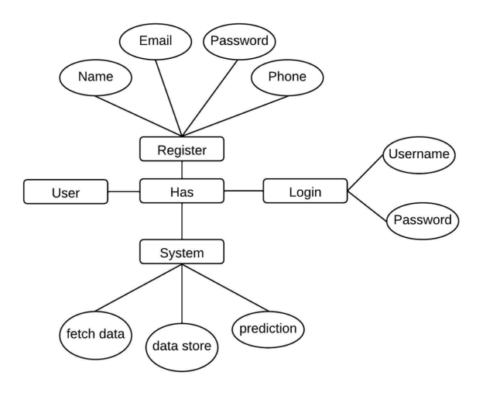

FLOWCHART:
Flow diagrams are graphical representations of workflows of stepwise activities and actions with support for choice, iteration and concurrency. In the Unified Modeling Language, Flow diagrams can be used to describe the business and operational step-by- step workflows of components in a system. An activity diagram shows the overall flow of control. A Flow diagram shows the overall flow of control. Flow diagrams are constructed from a limited repertoire of shapes, connected with arrows.
Flow diagrams are constructed from a limited repertoire of shapes, connected with arrows.
The most important shape types:
● The rectangle represents Flow .
● Diamonds represent decisions.
● Bars represent the start (split) or end (join) of concurrent activities.
● A rectangle represents the start (initial state) of the workflow.
● An end rectangle represents the end (final state).
● Arrows run from the start towards the end and represent the order in which activities happen.

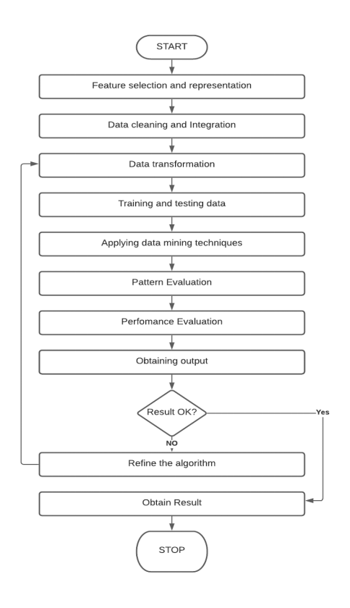

Context level Data Flow Diagram:
Data Flow Diagram (DFD) is a graphical representation of data flow in any system. It is capable of illustrating incoming data flow, outgoing data flow and store data. There is a major difference between data flow diagrams and flowchart.. Data flow diagrams illustrate flow of data in the system at various levels. Data flow diagram does not have any control or branch elements.Data flow diagram describes anything about how data flows through the system.Sometimes people get confused between data flow diagram and flowchart. The flowchart illustrates flow control in program modules

Components of Data Flow Diagram:

Entities:

Entities include source and destination of the data. Entities are represented by a rectangle with their corresponding names.

Process:
The tasks performed on the data are known as processes. Process is represented by a circle. Somewhere round edge rectangles are also used to represent the process.

Data Storage:
Data storage includes the database of the system. It is represented by a rectangle with both smaller sides missing or in other words within two parallel lines.

Data Flow:
The movement of data in the system is known as data flow. It is represented with the help of an arrow. The tail of the arrow is the source and the head of the arrow is the destination.

DFD Level 0:-

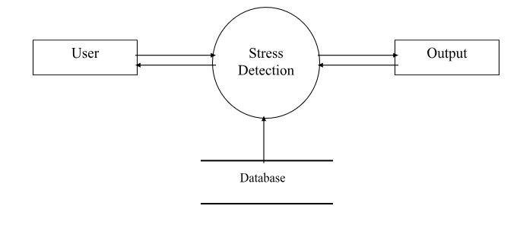

DFD Level 1:-

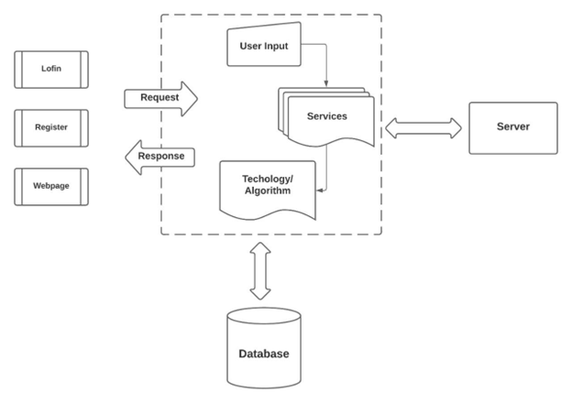

Activity diagram:
Activity diagrams are graphical representations of workflows of stepwise activities and actions with support for choice, iteration and concurrency. In the Unified Modeling Language, activity diagrams can be used to describe the business and operational step-by- step workflows of components in a system. An activity diagram shows the overall flow of control. An activity diagram shows the overall flow of control. Activity diagrams are constructed from a limited repertoire of shapes, connected with arrows.
Activity diagrams are constructed from a limited repertoire of shapes, connected with arrows.
The most important shape types:
● Rounded rectangle represents activities.
● Diamonds represent decisions.
● Bars represent the start (split) or end (join) of concurrent activities.
● A black circle represents the start (initial state) of the workflow.
● An encircled black circle represents the end (final state).
● Arrows run from the start towards the end and represent the order in which activities happen.

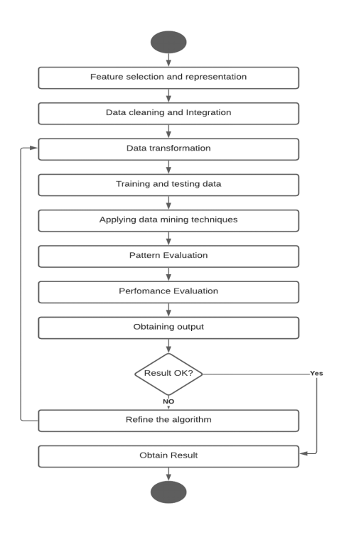

Class diagram:
It is a model which is used to show the classes constituting a system and their interrelationship. It is based on UML. Only the important attributes and methods are shown in Class diagrams. In the initial period of analysis, the important attributes of the classes, which must be captured and the functionalities provided by the class may not be very clear. As the analysis progresses, the attributes and methods may be added. If more focus is on interrelationships of classes, then the attributes and methods may not be shown in the class diagram.
The class diagram is used to identify and classify the objects which constitute a system. It also includes the important attributes of the objects which must be captured.

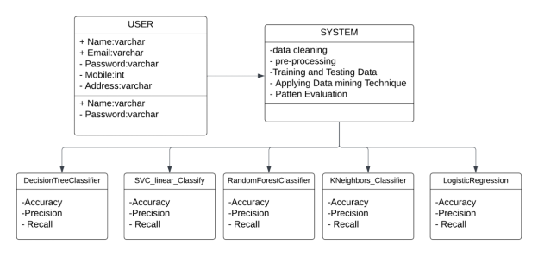

Use Case Diagram:
A use case diagram is a dynamic or behavior diagram in UML. Use case diagrams model the functionality of a system using actors and use cases. Use cases are a set of actions, services, and functions that the system needs to perform. In this context, a "system" is something being developed or operated, such as a web site. The "actors" are people or entities operating under defined roles within the system.
Use case diagrams are valuable for visualizing the functional requirements of a system, which will translate into design choices and development priorities.
They also help identify any internal or external factors that may influence the system and should be taken into consideration.
They provide a good, high-level analysis from outside the system. Use case diagrams specify how the system interacts with actors without worrying about the details of how that functionality is implemented.

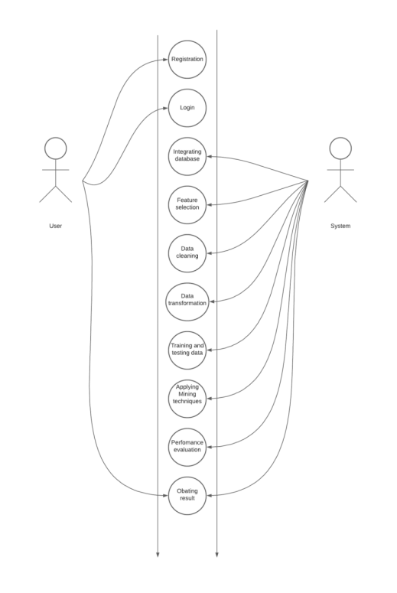

Deployment Diagram
A deployment diagram is a structure diagram that shows the architecture of the system as well as the deployment (distribution) of software artifacts to deployment targets.
Artifacts represent concrete elements in the physical world that are the result of a development process. A deployment diagram is usually represented by a node, which is either a hardware device or some software execution environment. Nodes could be connected through communication paths to create networked systems of arbitrary complexity.
Note that that component was directly deployed to nodes in UML 1.x deployment diagrams. In UML 2.x, artifacts are deployed to nodes, and artifacts could manifest (implement) components. Components are deployed to nodes indirectly through artifacts.
Deployment diagrams could describe architecture at the specification level (also called the type level) or at the instance level (similar to class diagrams and object diagrams).
The specification-level deployment diagram shows an overview of the deployment of artifacts to deployment targets without referencing specific instances of artifacts or nodes.
The instance-level deployment diagram shows the deployment of instances of artifacts to specific instances of deployment targets. It could be used, for example, to show differences in deployments in development, staging, or production.

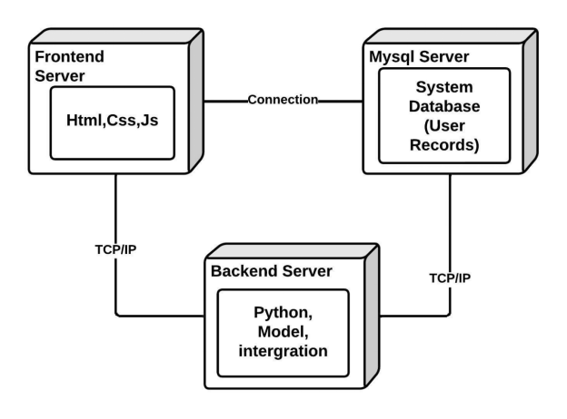

Chapter 8

ADVANTAGES

Stress detection using machine learning involves leveraging various algorithms to analyze patterns in data and identify signs of stress in individuals. One of the key advantages of employing machine learning for this purpose is its ability to process large volumes of data quickly and accurately. Algorithms like Support Vector Machines (SVMs) can effectively classify data into different stress levels based on features such as heart rate variability, skin conductance, and speech patterns. SVMs work well with high-dimensional data and can handle non-linear relationships between variables, making them suitable for complex stress detection tasks. Another advantage lies in the flexibility of machine learning algorithms like Random Forests and Gradient Boosting Machines, which can adapt to new data and refine their models over time, enhancing the accuracy of stress detection predictions. Additionally, neural network models such as Convolutional Neural Networks (CNNs) excel at processing sensory data like images or audio, allowing for a more comprehensive analysis of stress-related cues. Overall, the diverse range of machine learning algorithms available enables robust and efficient stress detection systems with high accuracy and adaptability.

Chapter 10
Results and Discussion
& CONCLUSION

Results and Discussion:

In the project on Stress Detection with Machine Learning, various algorithms were compared to determine their effectiveness in identifying and analyzing stress patterns. The algorithms considered included Support Vector Machines (SVM), Random Forest, and Gradient Boosting. The dataset used for training and testing consisted of physiological signals such as heart rate variability, skin conductance, and body temperature, along with self-reported stress levels.

Results from the experiments indicated that Gradient Boosting outperformed the other algorithms in terms of accuracy and robustness. It demonstrated a higher ability to detect subtle changes in stress levels and had a lower rate of false positives compared to SVM and Random Forest. However, Random Forest also showed promising results, especially when dealing with noisy data and handling missing values.

Discussion around these findings revolved around the complexity of the algorithms and their interpretability. While Gradient Boosting offered superior performance, its black-box nature made it challenging to understand the underlying features driving the stress detection process. On the other hand, SVM provided more transparent results, making it easier to interpret but at the cost of slightly lower accuracy compared to Gradient Boosting.

Overall, the project highlighted the importance of selecting the right machine learning algorithm based on the specific requirements of stress detection tasks. It also emphasized the need for further research to develop hybrid models or ensemble techniques that combine the strengths of different algorithms for more accurate and interpretable stress detection systems.

Feature

Detecting stress using machine learning involves developing algorithms that can analyze various features to identify patterns indicative of stress levels in individuals. These features can include physiological signals like heart rate variability, skin conductance, and body temperature, as well as behavioral indicators such as speech patterns, facial expressions, and typing speed. By collecting and processing data from sensors or user interactions, machine learning models can be trained to recognize correlations between these features and stress states.

To compare different machine learning algorithms for stress detection, one might consider techniques like support vector machines (SVMs), random forests, and deep learning models. SVMs are known for their effectiveness in classification tasks by finding optimal hyperplanes to separate different classes, while random forests excel in handling high-dimensional data and capturing complex relationships.

The choice of algorithm depends on factors like the complexity of the data, the size of the dataset, computational resources, and the desired accuracy. For instance, if dealing with multimodal data (e.g., physiological and behavioral), a combination of algorithms or an ensemble approach might be beneficial. Additionally, techniques such as feature selection, dimensionality reduction, and hyperparameter tuning play crucial roles in optimizing model performance for stress detection applications.

Overall, the goal is to develop a robust and accurate machine learning system that can effectively detect stress levels based on a diverse range of features, contributing to better understanding and management of stress-related issues in various contexts such as healthcare, workplace environments, and personal wellness applications.

CONCLUSION:

The project on stress detection using machine learning techniques involved exploring various algorithms to determine their effectiveness in identifying and classifying stress patterns. Different machine learning algorithms were compared and evaluated based on their performance metrics such as accuracy, precision, recall, and F1 score. Through rigorous experimentation and analysis, the project aimed to identify the most suitable algorithm or combination of algorithms for accurately detecting stress levels. This process involved preprocessing the data, feature selection, training the models, and fine-tuning hyperparameters to achieve optimal results. The conclusion of the project highlighted the strengths and weaknesses of each algorithm, providing valuable insights into their applicability and performance in real-world stress detection scenarios.

Chapter 11

BIBLIOGRAPHY

Bibliography:

[1] Palmer S 1989 The Health and Safety Practitioner, 8 16-18

[2] Ahuja R and Banga A 2019 International Conference on Pervasive Computing Advances and Applications – PerCAA 2019 125 349-353

[3] Bobade P and Vani M 2020 Proceedings of the Second International Conference on Inventive Research in Computing Applications (ICIRCA-2020) 51-58

[4] Vaikole S Mulajkar S More A Jayaswal P and Dhas S 2020 International Journal of Creative Research Thoughts (IJCRT) 8 5 2239-44

[5] Schmidt P Reiss A Duerichen R Marberger C and Laerhoven K V 2018 Proceedings of the 20th ACM International Conference on Multimodal Interaction 400-408

[6] Padmaja B Rama Prasad V V and Sunitha K V N 2018 International Journal of Machine Learning and Computing 8 1 33-38 [7] Pandey P S 2017 2017 17th International Conference on Computational Science and Its Applications (ICCSA)

[8] Ghaderi A Frounchi J and Farnam A 2015 22nd Iranian Conference on Biomedical Engineering (ICBME) 93-98

[9] Sandulescu V Andrews S Ellis D Bellotto N and Mozos O M 2015 International Work-Conference on the Interplay Between Natural and Artificial Computation 526-532

[10] Zhang X Xu C Xue W Hu J He Y and Gao M 2018 Sensors 2018 18 11 3886

[11] Ferdinando H Ye L Seppӓnen T and Alasaarela E 2014 Australian Journal of Basic and Applied Sciences. 8 14 50-55

[12] Tiwari S Agarwal S Muhammad Syafrullah and Adiyarta K 2019 Proc. EECSI 2019 - Bandung, Indonesia 6 107-111

[13] Zainudin Z Shamsuddin S M and Hasan S 2019 The International Conference on Advanced Machine Learning Technologies and Applications (AMLTA2019) 921 43-51

Chapter 11

SCREENSHOTS



Chapter 12

SOURCE CODE

